not an elegy for Mike Brown: Danez Smith
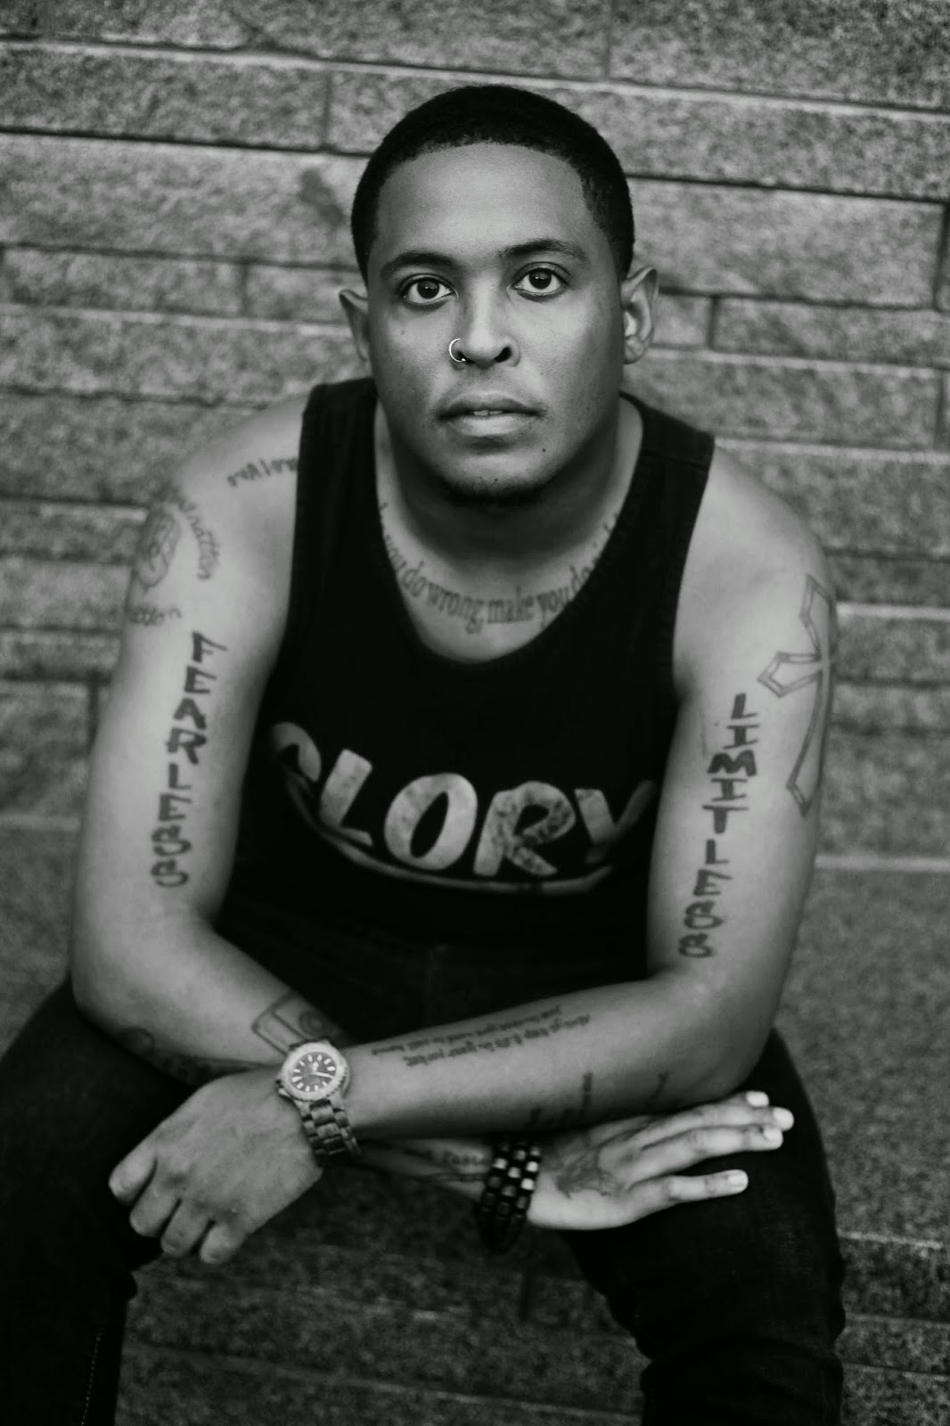
I am sick of writing this poem
but bring the boy. his new name
his same old body. ordinary, black
dead thing. bring him & we will mourn
until we forget what we are mourning
& isn’t that what being black is about?
not the joy of it, but the feeling
you get when you are looking
at your child, turn your head,
then, poof, no more child.
that feeling. that’s black.
\\
think: once, a white girl
was kidnapped & that’s the Trojan war.
later, up the block, Troy got shot
& that was Tuesday. are we not worthy
of a city of ash? of 1000 ships
launched because we are missed?
always, something deserves to be burned.
it’s never the right thing now a days.
I demand a war to bring the dead boy back
no matter what his name is this time.
I at least demand a song. a song will do just fine.
\\
look at what the lord has made.
above Missouri, sweet smoke.
Used by permission.
Photo by: Travis Chanter
Danez Smith is the author of the collection [insert] Boy (forthcoming, YesYes Books) & the chapbook hands on ya knees (Penmanship books, 2013). Danez is a 2014 Ruth Lilly & Dorothy Sargent Rosenberg Poetry Fellowship Finalist. Danez is the recipient of fellowships from the McKnight Foundation, Cave Canem, VONA, & elsewhere. He is a founding member of the multi-genre, multicultural Dark Noise Collective. His writing has appeared in Poetry Magazine, Ploughshares, Beloit Poetry Journal, & elsewhere. In Poetry Slam, he is the 2014 NUPIC Champion, a 2011 IWPS finalist, the reigning 2-time Rustbelt Individual Champion & was on 2014 Championship Team Sad Boy Supper Club. He writes & lives between Oakland, CA & St. Paul, MN.

Please feel free to forward Split This Rock Poem of the Week widely. We just ask you to include all of the information in this post, including this request. Thanks!

